TASK 3: Motion Simulation

Project Title: Four-Bar Linkage Motion Analysis
Software: SolidWorks Motion
Objective
To simulate the motion of a four-bar linkage mechanism.

Mechanism Model

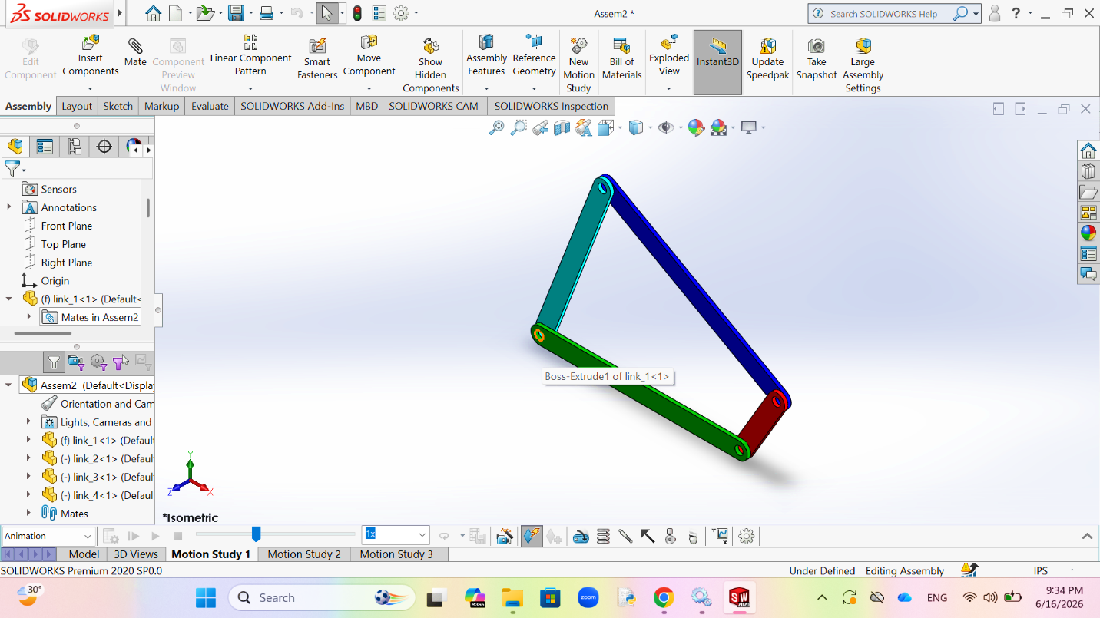
Motion Setup:
- Fixed Ground Link_1
- Rotary Motor = 30RPM

Motor:

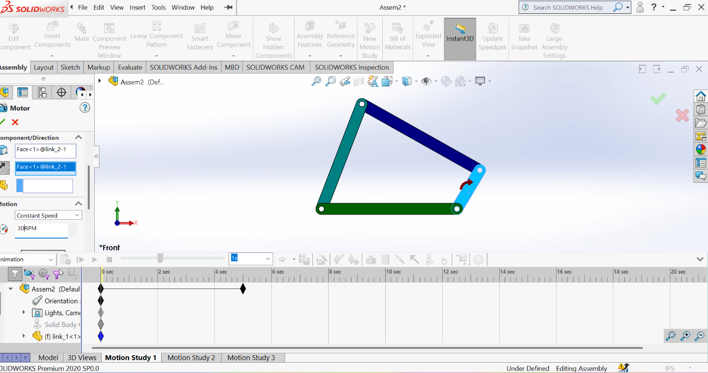

Motion Results:

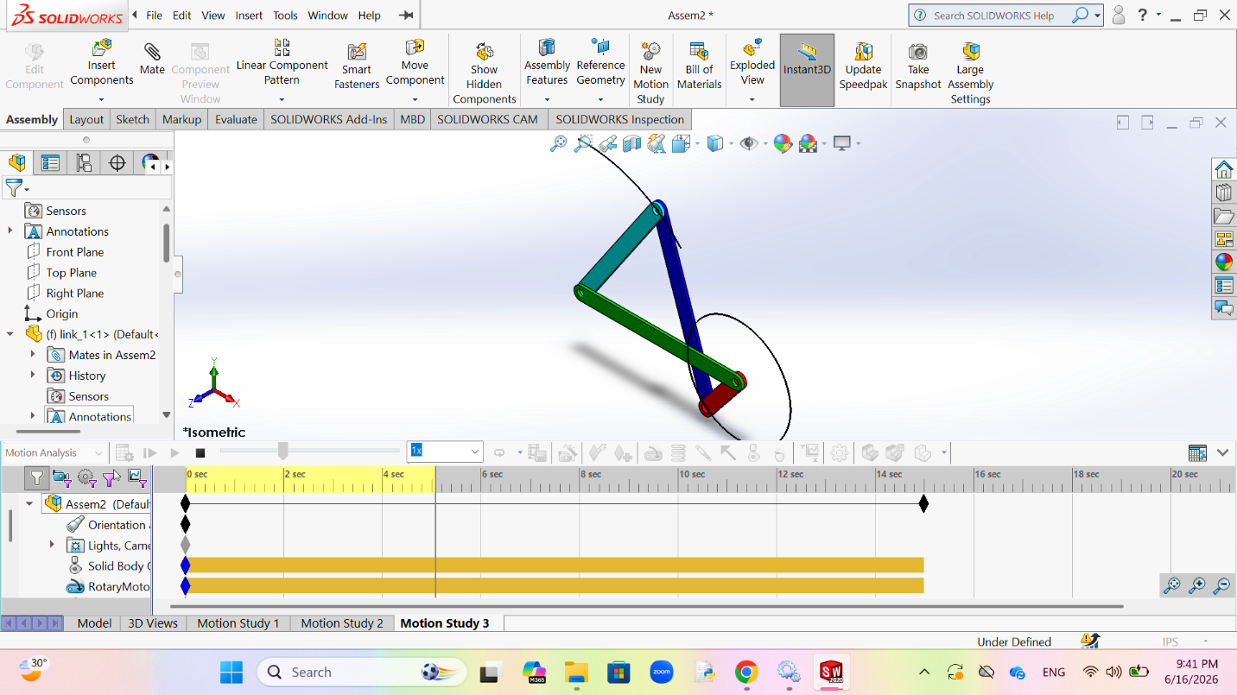

Observation:
The four-bar linkage mechanism was successfully simulated and motion behavior was observed.

Conclusion
The mechanism was analyzed using motion simulation to observe the movement

